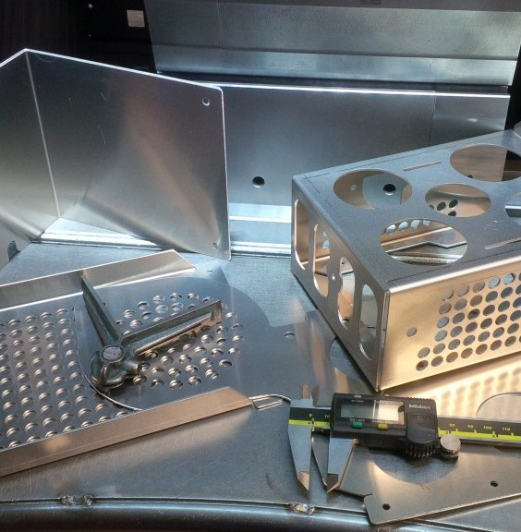BALA PRITAM ROLL FORM

High-Ǫuality Roll Sheet Metal Working Machinery.

Our machinery ensures precise and efficient metalworking.

Febuary 2024

Sheet Metal Working Machinery

Table of Contents

Introduction 3

Tile Sheet Rollformers.....

Tile Sheet Production Line 6

Ridge Cap Machine 8

Roofing and Cladding Profile Rollformers

Rollformer for Trapeze Profile 10

Double-deck Rollformer 12

Slate Profile Rollformer 14

Table of Profiles 16

Cut-to-length and Slitting Machinery

Cut-to-length and Slitting Unit 1250 mm / 1.25 mm 18

Cut-to-length and Slitting Unit 1500 mm / 2.0 mm 19

Re-coiler and Felt Brake 20

Additional Equipment.....

Decoilers 5 to 15 tons 22

Stackers 23

Wrapping Machine 24

Downspout and Elbow Machine 25

Gutter Machines 26

Customised Rollformers for Roofing Accessories 27

##### Introduction

**BALA PRITAM ROLL FORM**

has been in business over fifteen years and distributes its products worldwide. We offer wide range of expertise and knowledge in both machine and factory design,

and in our own roll-forming mill we can test and develop new methods for our customers ́´ benefit.

Our customer lies at the heart of our philosophy. We are committed to making equipment that makes your business more productive. Our sales and design team takes the time to get a clear picture of your exact needs. Whether it’s a single piece of equipment or a totally

new state of the art manufacturing system, we help you clearly set your equipment objectives, and then develop systems to meet these objectives.

Your production requirements, unique manufacturing situation and approach to business are all key ingredients in the design of your equipment. We begin with clearly defined plans based on your needs. The tooling and equipment we produce for you is how we keep our promise.

We understand that your customer expects you to meet their deadlines with quality products that are on time, that fit right, and that deliver the strength and durability to stand the

test of time. We also understand that your business is in a highly competitive environment. The metal construction components you manufacture must do all of this, with quality and efficiency, and at a price your customers can afford.

Starting with our highly trained and experienced sales team, everyone at balapritamrollformer is committed to your needs. This partnership focuses on you and your goals through open

lines of communication and service, which is fundamental to our promise.

On-time delivery, increased productivity in your manufacturing process and 100% aftersales commitment – these are not just goals for us – this is the way we do business.

plot no.17,Nea[r GBLConvent School, Dabua P](http://balapritamrollform.com/)ali Road, Faridabad, Haryana-121004 India contact no

+91- 9953573713 [https://balapritamrollform.](http://balapritamrollform.com/)in/

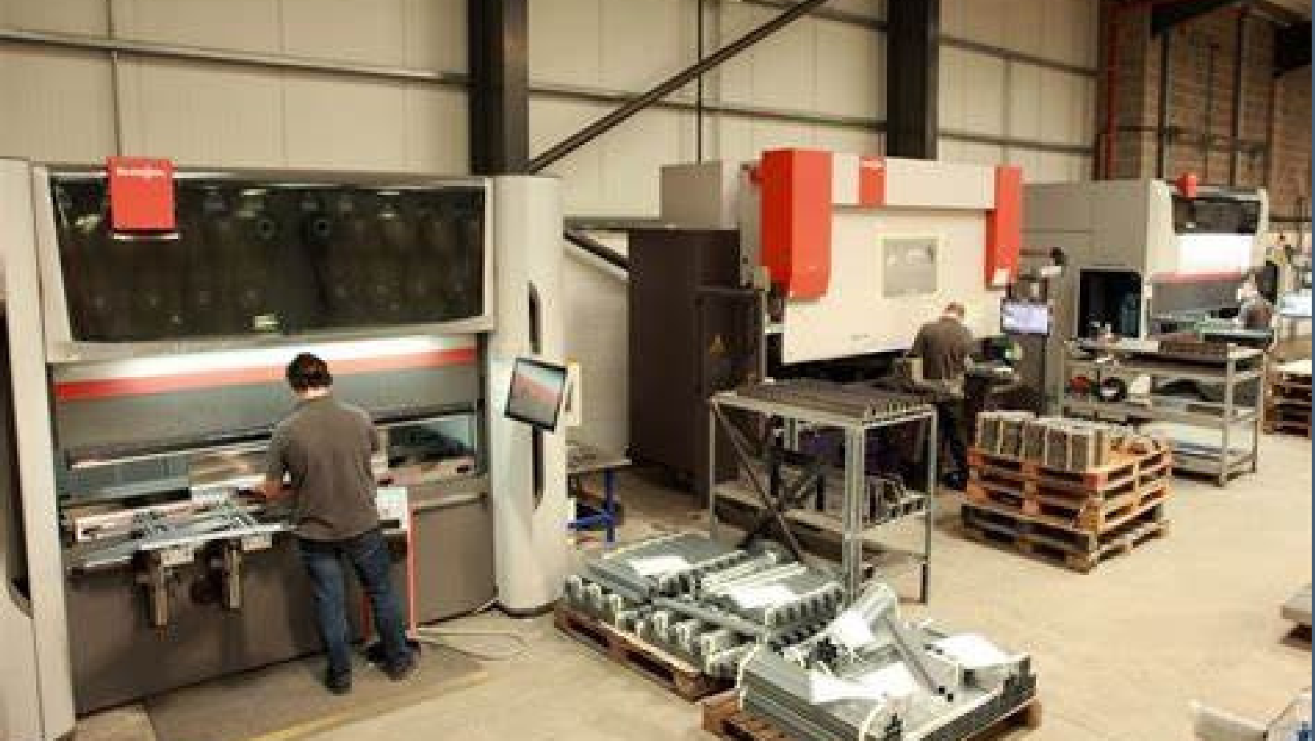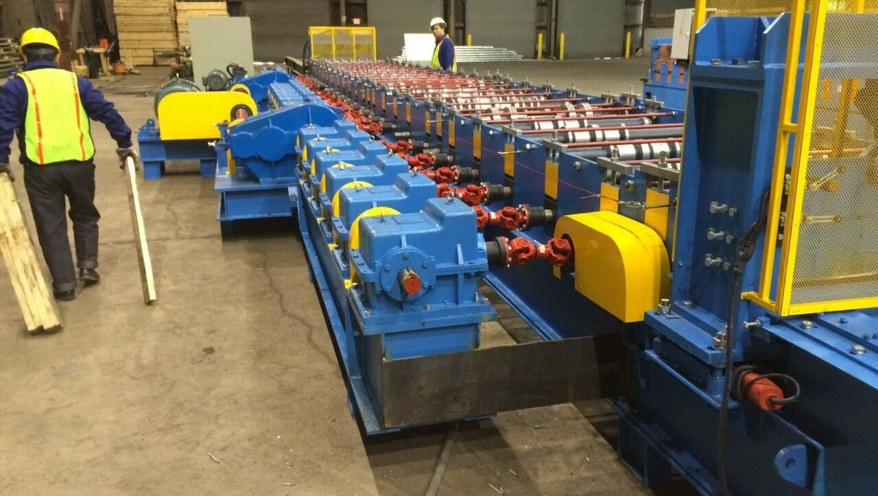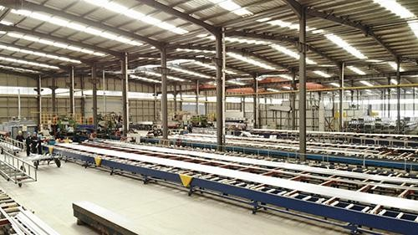

Tile Sheet Rollformers

Our tile sheet rollforming line meets the production demands of today´s heavy industry. The rollformer is drivepowerful electric motor. The press and the post cutter

are operated by an 11 kW hydraulic unit. With an efficient production speed of 8 metres per minute you can reach production output of 15 tons in one shift.

An advanced Programmable Logic Controller (PLC) unit is provided with an LCD monitor and the necessary electrical components for manual and automatic line operation. The control unit controls the operations of the roll forming machine, press,

cutter and stacker.

Our advanced software enables you to modify the distance between pressings and the length of the eaves section. Up to 10 different lengths and 1000 pieces can be programmed for each production set. With the latest pressing tool it is possible to press various step heights (minimum 14 mm / maximum 25 mm) just by placing additional plates under the tool set. This takes approximately 5 minutes.

These features make our Tile Sheet Line highly efficient and user friendly. The process is fully [automated and can easily be ope](http://balapritamrollform.com/)rated by one man.

Contact number +919953573713 [https://balapritamrollform.](http://balapritamrollform.com/)in/

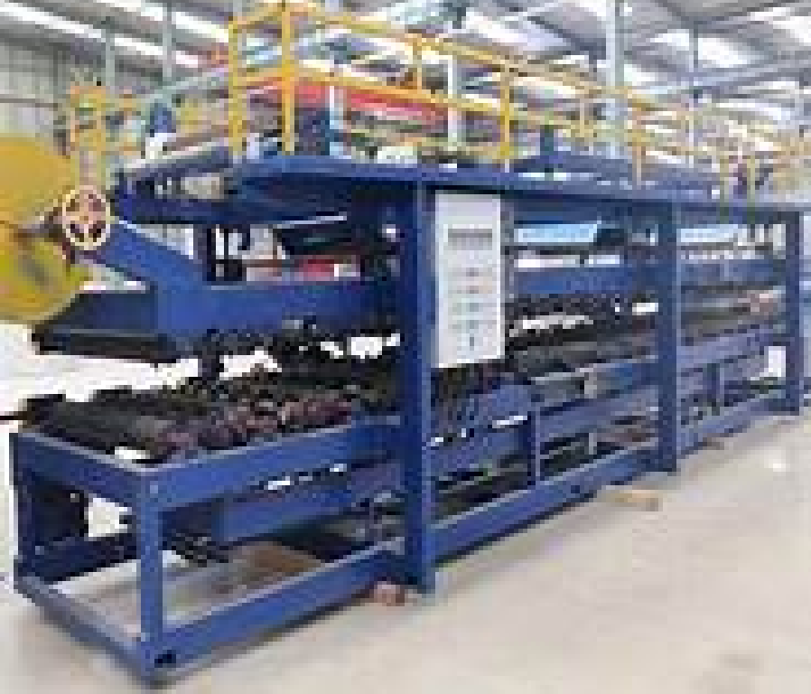Tile Sheet Production Line Material Requirements Thickness

0.5 mm Width of strip

1250 mm or for customized width For coated steel

Steel quality

DIN EN 10346: S220GD+Z – S320GD+Z

Profiilikeskus tile sheet rollformers are the product of over 20 years’ experience of designing high-quality rollforming machines for the international market, and simultaneously using our own rollformers to manufacture steel roofing for the demanding needs of our home market in Finland.

* Line includes: rollforming section, press, post-cutter, pre-cutter, automatic stacker, decoiler
* All our machines use the minimum of factory floor space
* Production speed 8 metres per minute (sheet length 6000 mm)., max. output 15 tonnes per shift
* Drive with electrical motor 7.5 kW for 16 chain-driven shaft pairs
* Hydraulic unit 11 kW for the press and post-cutter
* Under lapping side of the sheet has both water channel and capillary groove
* The height of the tile step and the distance for the first pressing at the eaves can also be adjusted

We accept only the most practical design solutions and standards. Operation of the tile sheet roll former is fully automated and the machine can easily be operated by one person.

Advanced software and an easy-to-use user interface allow for fast setting of the rollformer, including the tile length.

Address: Plot No.17, Near GBL Convent School, Dabua Pali Road, Faridabad, Haryana-121004 contact number https://balapritamrollform.in/ Tel. +91 -9953573713

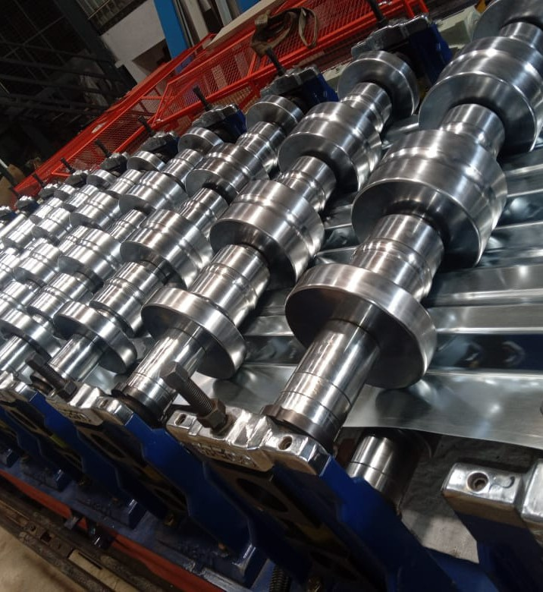Profile is asymmetric tile

Height of profile 36 mm Step height 16 to 20 mm

Total profile height 52 to 56 mm

Covering width 1065 mm

* Decoiler 7.5 tn, coil ID 508–610 mm
* Expansion with wedge mechanism
* Hydraulic wheeling and tightening of coil

The press tooling is made from tool steel 100MnCrW4. The movement of the pressing tool is controlled by two hydraulic cylinders, with a working pressure of 160 bar.

The cutting blades of the post cutter are made of hardened tool steel and are 16 mm thick. The blades have,

therefore, a long service life and can be sharpened several times. The rollformer, press and cutter can be steered from the control unit either in manual or automatic drive.

The cutter is a guillotine type eccentric cutter and is operated by hydraulic motor. The press and cutter are stationary (not flying).

Automatic stacker 6 m and motorized roller line with side movement 8 m. Pneumatically operated stacking arm.

183 mm

1100 mm

25 mm

213 mm

1065 mm

36 mm

Height of profile 25 mm

Step height from 14 to 25 mm

Total profile height from 39 to 50 mm Covering width 1100 mm

Balapritamrollform address-plot no.17,Near GBL Convert School, Dabua Pali Road, Faridabad, Haryana-121004 India Tel. +919953573713 Con+919953573713 [balapritamrollforme@gmail.com](mailto:balapritamrollforme@gmail.com)

Tile Sheet Rollformers 7 Ridge Cap Machine

An elegant half round ridge cap is needed to complete the finishing touch to the Tile sheet roof.

Our compact ridge cap rollformer is provided with necessary electrical components for manual and automatic running of the line. Preset the number of pressings in a piece

into the parameters and all you need to enter in production mode is the piece amount.

Pneumatic spraying syste

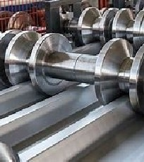Profile Is Asymmetric Tile

Height of profile 25 mm

Step height from 14 to 25 mm Total profile height from 39 to 50 mm Covering width

Height of profile 25 mm

Step height from 14 to 25 mm Total profile height from 39 to 50 mm Covering width

|  |  |
| --- | --- |
| • | Decoiler 7.5 tn, coil ID 508–610 mm |
| • | Expansion with wedge mechanism |
| • | Hydraulic wheeling and tightening of coil |

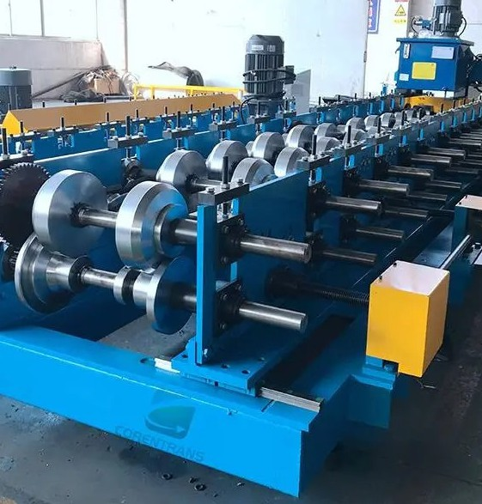

The press tooling is made from tool steel 100MnCrW4. The movement of the pressing tool is controlled by two hydraulic cylinders, with a working pressure of 160 bar. The cutting blades of the post cutter are made of hardened tool steel and are 16 mm thick. The blades have, therefore, a long service life and can be sharpened several times. The rollformer, press and cutter can be steered from the control unit either in manual or automatic drive.

The cutter is a guillotine type eccentric cutter and is operated by hydraulic motor. The press and cutter are stationary (not flying). Automatic stacker 6 m and motorized roller line with side movement 8 m. Pneumatically operated stacking arm

# Ridge Cap Machine

Pneumatic spraying system

Width of strip - 416 mm +/- 10mm

An elegant half round ridge cap is

needed to complete the finishing

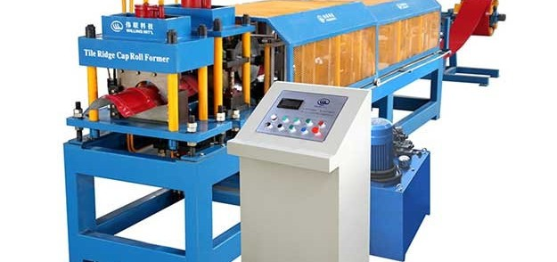touch to the Tile sheet roof. Our compact ridge cap rollformer is provided with necessary electrical components for manual and automatic running of the line. Preset the number of pressings in a piece

into the parameters and all

you need to enter in produc

Thickness - 0.5 - 0.6 mm Pre-coated steel

Electrical drive and Hydraulic press and cutte

Roofing And Cladding Profile Rollformers

**We supply and manufacture Roofing and Cladding Profile Rollformers, including Trapeze Rollformers, Double-deck Rollformers and Slate Profile Rollformers for small**

**to large-scale production volumes. The main differences are in the machine construction and production speed. Light machinery**

**The frame in our economic trapeze rollformer is solid and the shafts are attached to the frame. This enables you to rollform raw materials to thicknesses of between**

**0.45 – 0.6 mm. Production speed varies from fi5 to 20 metres per minute.**

**A user friendly control unit is provided with an LED-monitor and the necessary electrical components for manual and automatic line operation. This unit controls the operation of the rollforming machine and the cutter. Up to 8 different lengths and 999 pieces per length can be programmed.**

**Heavy-duty machinery**

**In our heavy-duty machinery the shafts are attached to adjustable stations, enabling you to rollform raw material up to a thickness of 0.9 mm. An efficient production speed of 40 metres per minute guarantees maximum output. When the rollformer is equipped with a pre-cutter there is no waste left over when changing the coil.**

**An advanced Programmable Logic Controller (PLC) control unit is provided with an LCD-monitor and the necessary electrical components for manual and automatic line operation. This unit controls the operation of the rollforming machine, cutter and stacker. Up to fi0 different lengths and fi000 pieces can be programmed.**

**All of our machinery meets European CE - safety requirements. Parts used in our control units are universal and easily obtainable worldwide**

Roofing and Cladding Profile Rollformers

# Rollformer for Trapeze Profile

Profiilikeskus Trapeze and Corrugated Profile Rollformers provide dependable production solutions for both

low and high volume sheet metal manufacturing. All the structures and components, such as cutters and drives,

utilize only the most practical and fully-tested solutions.

The operation of our trapeze and corrugated profile rollformers is fully automated and the machines can easily be operated by one person. Advanced software and

an easy-to-use user interface allow for fast setting of the machines.

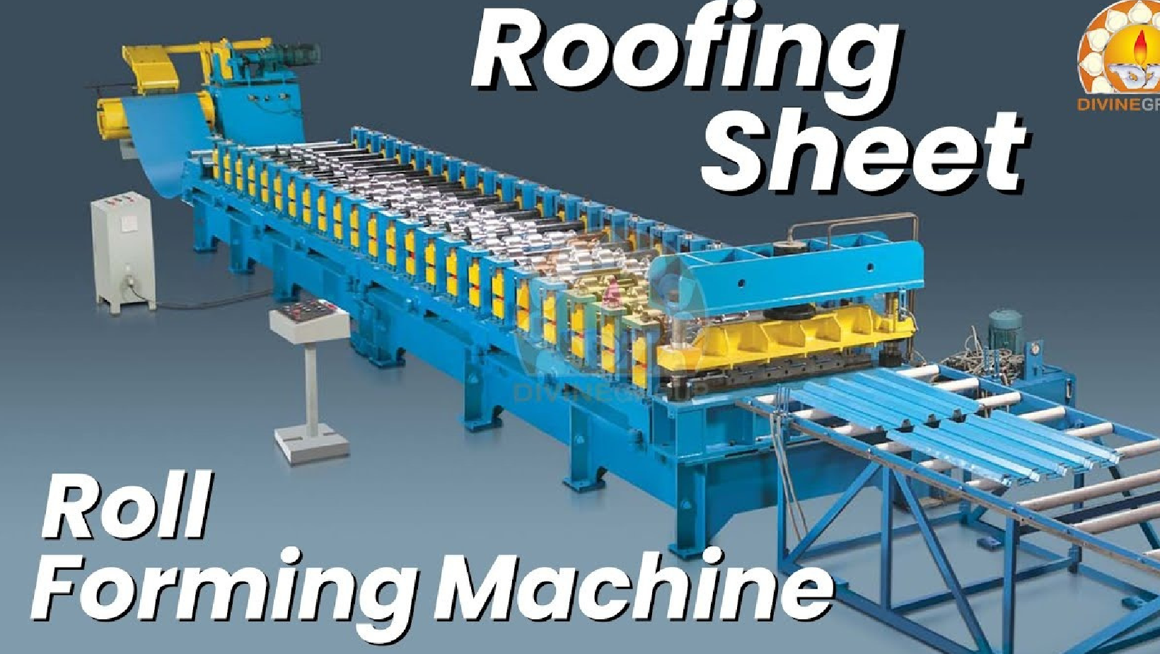

We are always ready to tailor and optimize our products to meet the individual requirements of your operations. This also includes several options for stackers and decoilers.

* Frame is a welded construction and made of heavy duty steel, quality st. 355 E.N. 10025
* Chain driven with electrical motors
* Forming rolls are fine-turned at Ra 0.8 surface and nitrocarburized
* Every forming roll is attached to the shaft by keyway. The spacers between the forming rolls are partly fixed with

keyway and partly free rotating. The relevant spacers which are part of the forming process are fitted

with bearings

* The forming rolls and spacers form a solid packet. In addition this packet is secured from both ends with axle nuts
* Adjustable statio

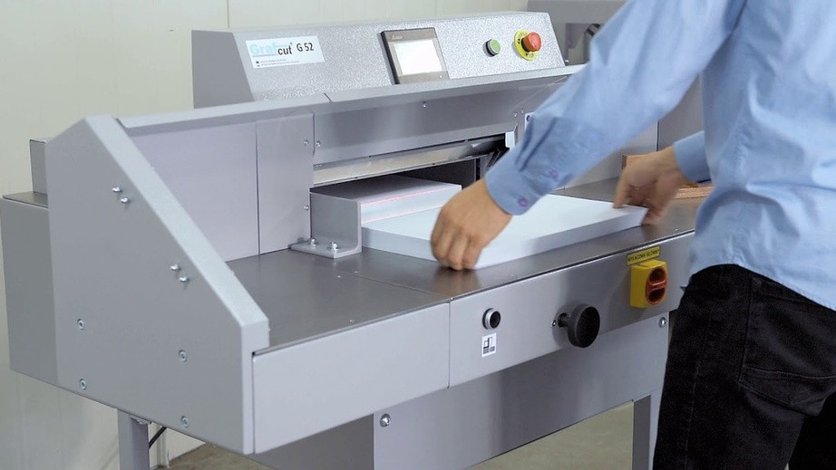Material Requirements

Thickness 0.45 up to 1.25 mm Width of strip Customized Coatings

Pre-coated and galvanized

Roofing and Cladding Profile Rollformers

Steel quality

DIN EN 10346: S220GD+Z – S350GD+Z

Speed 40 Metres/Minute excluding cutting time

Pre-cutter, electric

* + For cutting the flat sheet automatically when changing the coil
  + Control unit calculates the correct cutting point for the very last programmed sheet, stops the roll former and cuts the flat sheet

at the entry table before the first stations

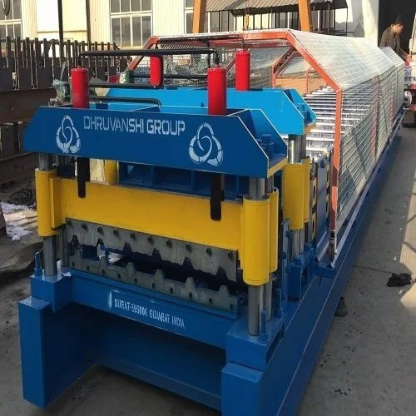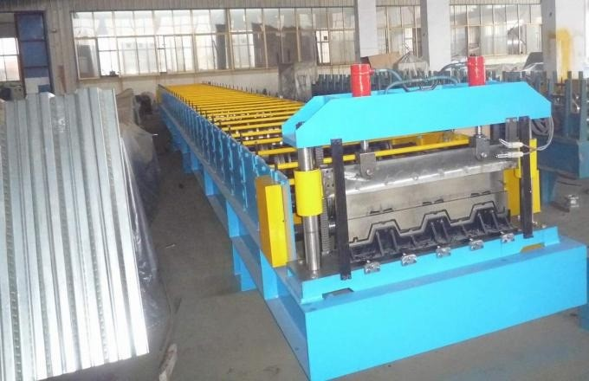All our rollforming machines use the minimum of factory floor space, as electric boxes are conveniently placed under the machine. Where space is severely limited, our double-deck rollformers provide the perfect solution for maximized capacity

Advanced software and an easy-to-use screen interface allow for fast setting of Profiilikeskus Trapeze Rollformers. By our Pro-C software, customer orders can be electronically transferred from office computer directly into the Rollformer’s interface. Several Rollformers can be connected into the Pro-C system

Roofing and Cladding Profile Rollformers

Double-deck Rollformer

If factory space is limiting your company’s prospects for growth, a Profiilikeskus double- deck rollformer offers the best solution to get more out of your premises. Our double-deck rollformer allows you to manufacture two different profiles on one rollformer

All the machine functions are controlled through an easy to- use screen interface. Rubbered draw- in rollers drive the

sheet automatically into the rollforming section. Thanks to this, the upper- level-sheet- entry can also be conveniently done at normal working heigh

* 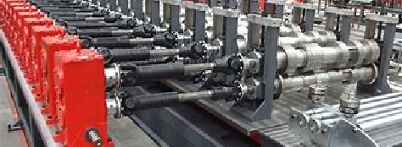Rollforming sections for two different profiles, post- cutters for the end products, pre-cutter for the flat sheet, automatic stacker.
* Both the lower and upper rollforming sections are driven by their own electric motors. Consequently, stress

for the drives and axles is minimized, which results in maximised machine reliability.

* For unloading, the inner part of the dual- frame stacker

rises above all the other structures, which enables the

safe removal of the completed stack, for example, by a

forklift

Roofing and Cladding Profile Rollformers 13

**Steel quality**

**DIN EN fi0346: S220GD+Z – S350GD+Z**

The rollformer can be steered from the control unit either

in manual or automatic drive. Steering and programming are made extremely user- friendly. The machine is controlled from a touchscreen and with switches in the control desk

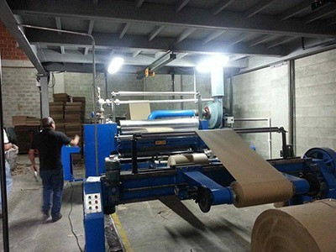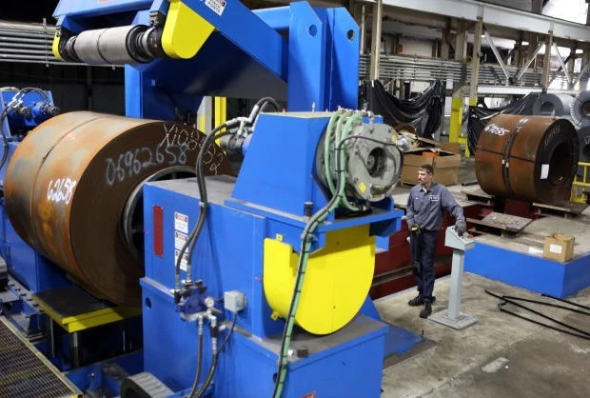The stacker level is automatically controlled by the machine software. During sheet production, the stacker height is automatically lowered step by step along with the increasing number of completed sheets. As a result, not even the first profile sheets of a stack are ever likely to fall down from a high position, ensuring 100-percent damage-free end products

#### The construction of stations allows for easy maintenance access to all

the parts of the machine

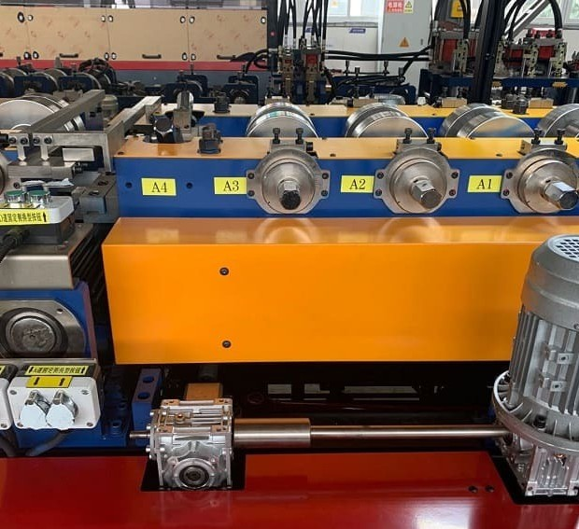

The rollforming sections are driven by their

own electric motors, which minimizes stress for the drives and axles

Roofing and Cladding Profile Rollformers

Slate Profile Rollformer

A Profiilikeskus slate profile rollformer is a completely new innovation. It opens up a fresh opportunity for steel roofing manufacturers to expand their business. The rollformer combines the traditional beauty of a slate roof with all the benefits allowed by modern steel roofing.

#### Thanks to the careful design of the profile shape, the slate profiles are quick and easy to install and they produce a hundred percent water proof structure. The profiles can be directly installed on roof trusses or rafters

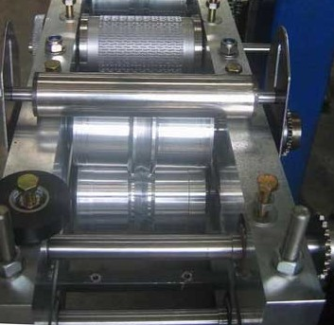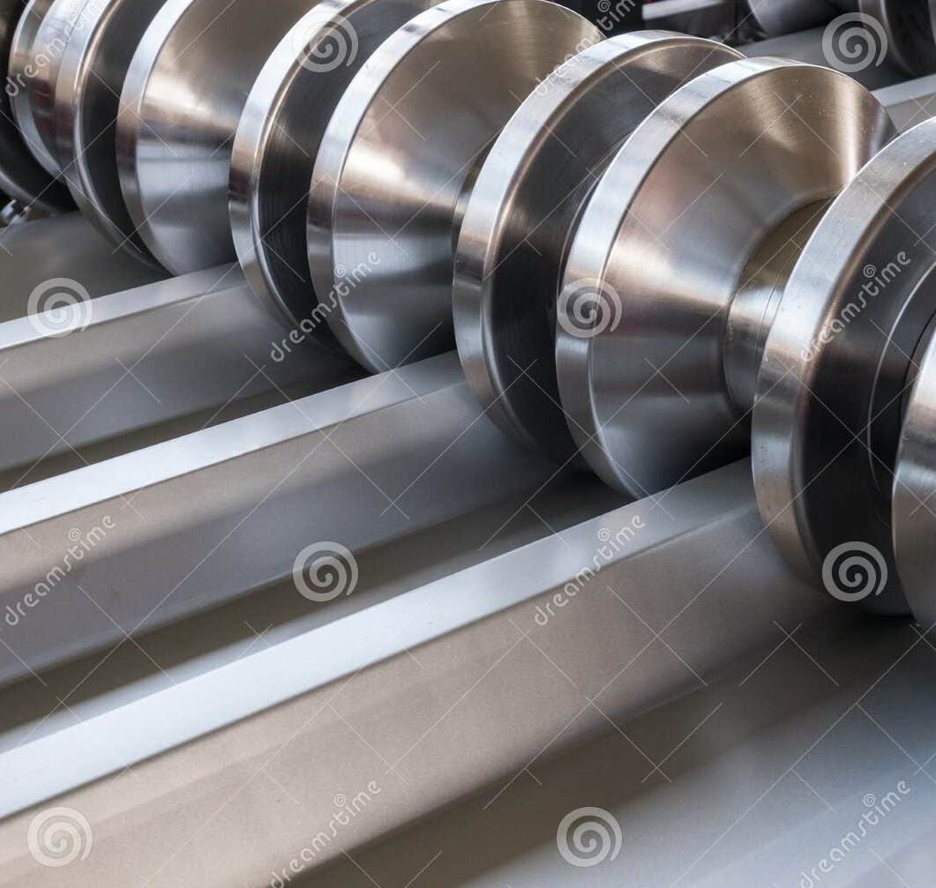

* The rollformer has a fully machined frame including machined stations. This results in extraordinary measurement accuracy of profiles and further ensures hundred

percent water proof roofing in all conditions

* All the machine controls are available

in one spot

through an easy-to-use interface screen

* Based on desired profile length, advanced software

determines the right cutting point

The slate profile embossing roll has its own motor

and hydraulics and the roll is automatically turned

off when joint support

pieces are being produced

The slate profile embossing roll has its own motor

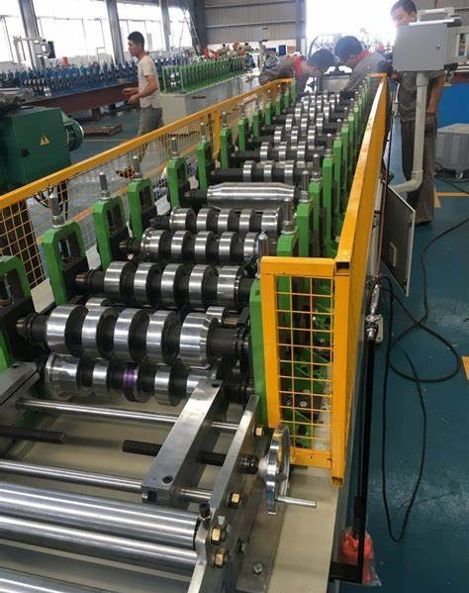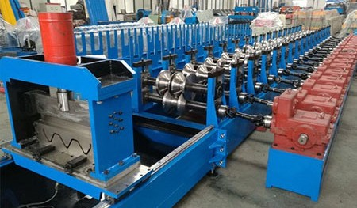

and hydraulics and the roll is automatically turned

off when joint support pieces are being produced.

Material Requirements

###### Thickness - 0.7mm

Width of strip - 406 ±5 mm

Roofing and Cladding Profile Rollformer

Coatings precoted-sheett Steel quality

DIN EN 10346: S220GD+Z – S320GD+Z

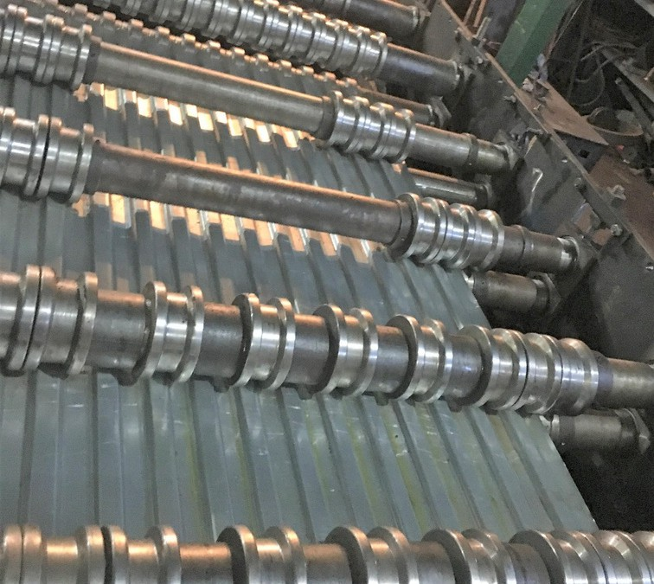

The same rollformer is used to produce the roofing profiles as well as the joint support pieces. Tool change is fast

and easy. No other special machines or accessories are needed to deliver state-of-the-art steel profile slate roofs

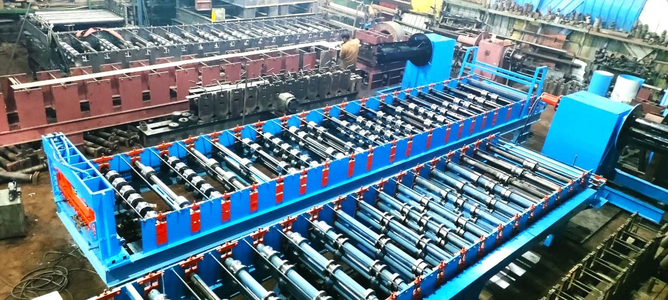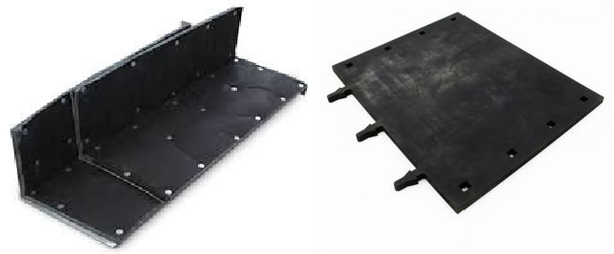

###### The slate profiles are quick and easy to install and they produce a hundred percent water proof structure. The profiles can be directly installed on roof trusses or rafters.

Roofing and Cladding Profile Rollformers

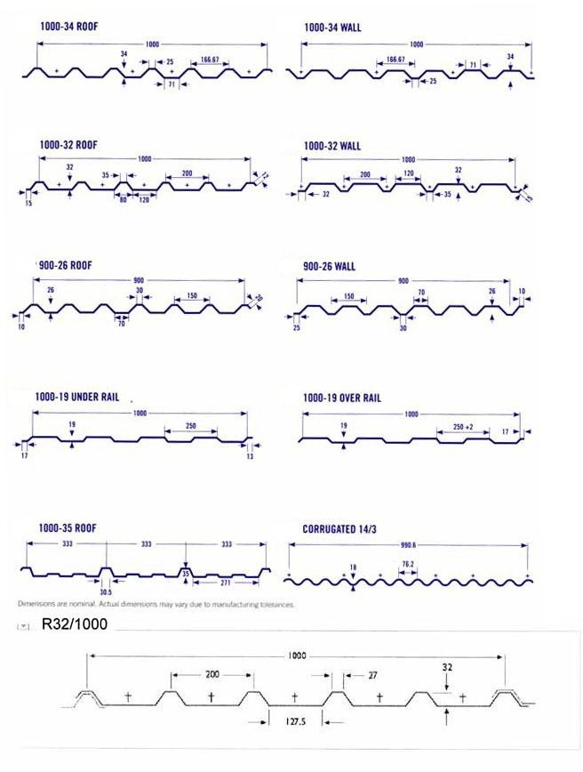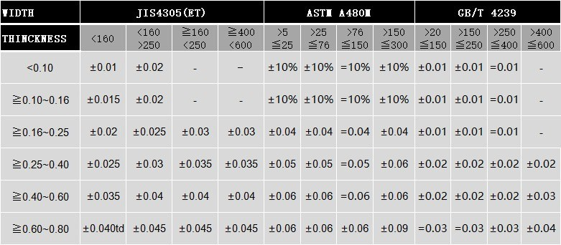

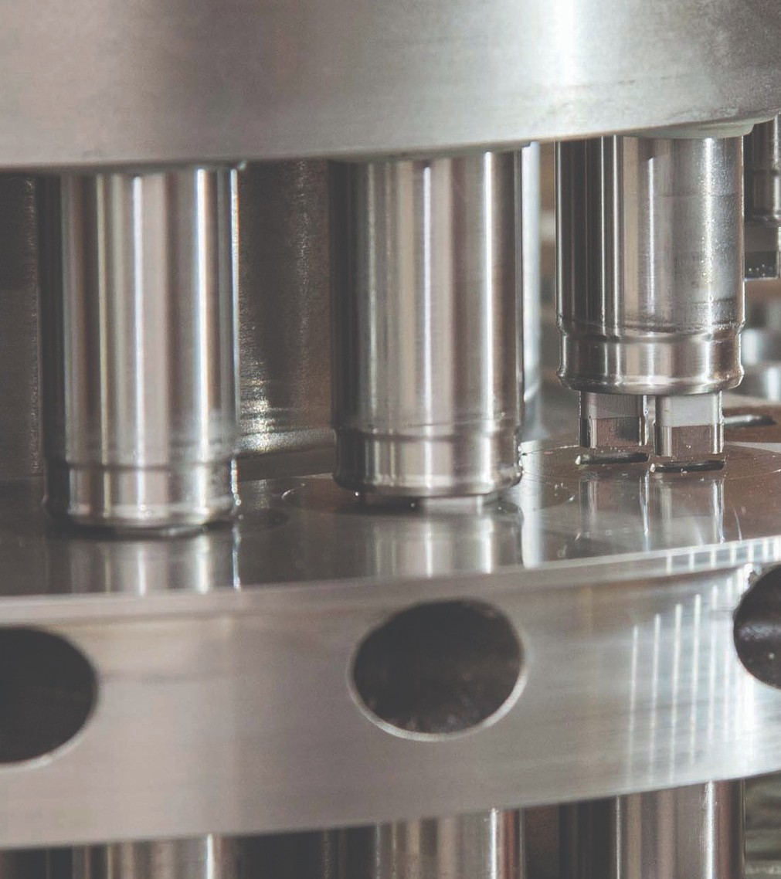

**Cut-to-length and Slitting Unit**

**fi250 mm / fi.25 mm**

A specially designer stacker is available for our cut-to-length and slitting units. The

stacker ensures efficient operation and damage- free sheet surfaces in all production

conditions

* 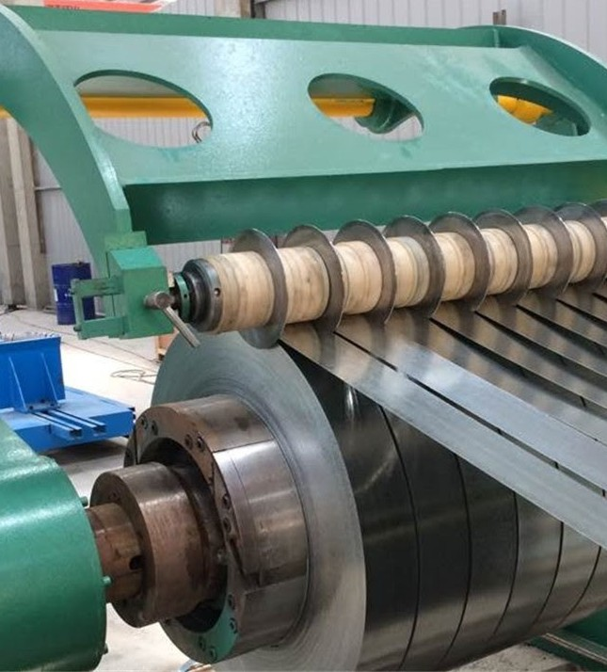Electrically operated 5 kW
* Shear for cut-to-length sheets and slitting unit with 5 blade pairs
* Max. strip width 1250 mm
* Strip thickness: steel 0.5–1.25 mm
  + Strip thickness 0.5–0.6 mm, slitting with max. 8 blade pairs
  + Strip thickness 0.7–0.9 mm, slitting with max. 5 blade pairs
  + Strip thickness 1.0–1.25 mm, slitting with max. 3 blade pairs
* PLC control unit with programmable length / pieces
* Repeat accuracy of length feed:

±0.5 mm/meter

* Straightening unit with 3 straightening rolls
* Steel quality DIN EN 10346: S220GD+Z - S350GD+Z

### Cut-to-length and Slitting Unit fi500 mm / 2.0 mm

 Max. strip width 1500 mm

 Strip thickness: steel 0.4 – 2.0 mm  Operated by servomotor 6.5 kW

 Guillotine cutter for the cut-to- length sheets and slitting unit with 5 slitting blade pairs

 Manual adjustment for slitting blades, with digital display, accuracy 0.1 mm

 Control unit for programming length and pieces. Maximum of twenty combinations of different length and pieces can be programmed for one production set

 Repeat accuracy of length feed:

±0.5 mm/meter

 Speed 25 m/min

 Straightening unit with 4 straightening rolls with 3 sup

* 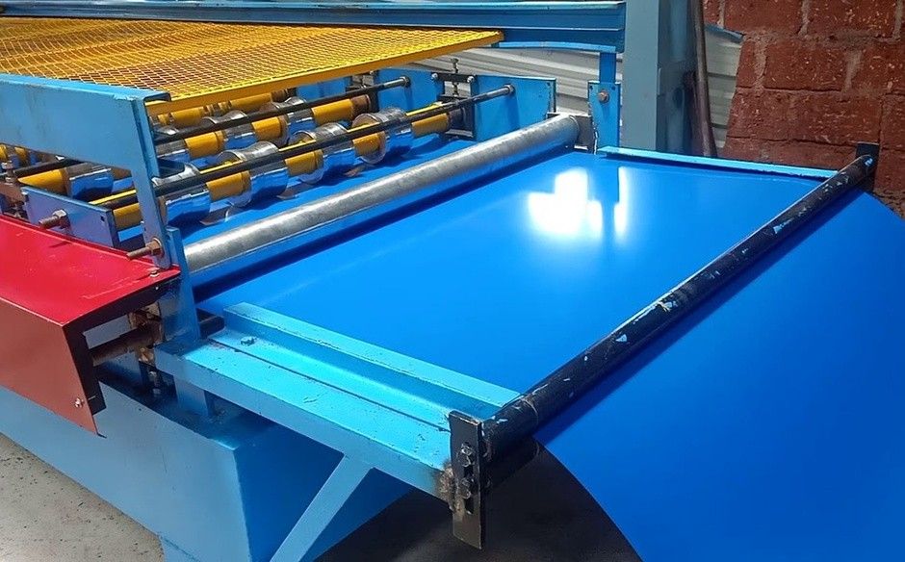Electrically controlled straightener
* The pressure of the straightener releases automatically when the machine stops for cutting. The minimum release is 1/10 mm and can be adjusted from the control

unit

* Urethane coated draw-in roller
* Cut-to-length shear slides on the rails by cam opening

the slitting blade section.

* Steel quality DIN EN 10346:

S220GD+Z - S350GD+Z

Available options:

 Additional slitting blades  Plastic film holder

 Pneumatic sheet entry table

Equip the Cut-to-length and slitting machine with Automatic stacker for the cut-to-length sheets or with Felt

brake and Recoiler for continuous slitting.

20 Cut-to-length and Slitting Machinery

Re-coiler and Felt Brake

**Re-coiler**

|  |  |
| --- | --- |
| • | Electrically operated |
| • | With own control switches |
| • | Forward and reverse operation |
| • | Hydraulic expansion of mandrel with wedge mechanism |

|  |  |
| --- | --- |
| • | With turned expansion plates 4 pcs |
| • | Strip guides |
| • | Hydraulic sheet gripper |
| • | Equipped with separating discs and coil car |

Coil specification Felt Brake

Inner diameter - 508 mm

Coil width - 1250 mm, 1500 mm Re-coiling capacity - 5 to 10 tons

 Strips go through the Felt Brake to the separating discs and re-coiler

 Tightens up the strips while recoiling  Pneumatically operated

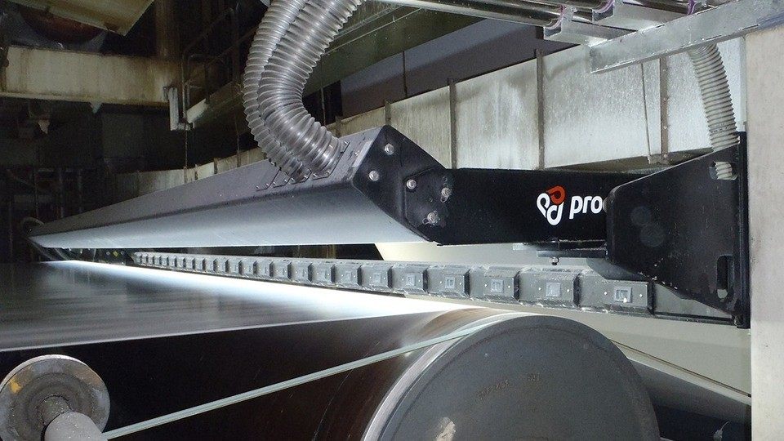 Braking force is adjusted manually

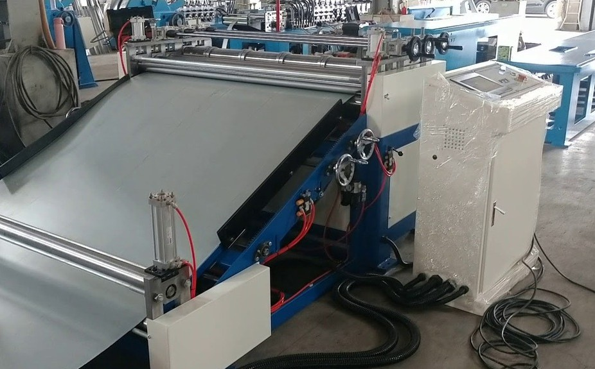

We are dedicated to designing and manufacturing both individual equipment and complete systems to fulfil the most demanding production requirements. By combining various additional equipment from our wide range, the whole production process for machine constructions can be made as efficient and automated as possible. A reliable and powerful Decoiler is an essential part of fluent operation.

Our Decoilers are available in 5 to 15 ton coils to meet your exact requirements.

From our large range of customized stackers you will easily find a solution that fits all the demands of your business and premises.

In addition, we manufacture and supply gutter and downspout machines as well as custom made rollformers for roofing accessories such as gable and straight cap flashing machines.

Please do not hesitate to ask about a rollformer to match your exact requirements.

We have the solution!

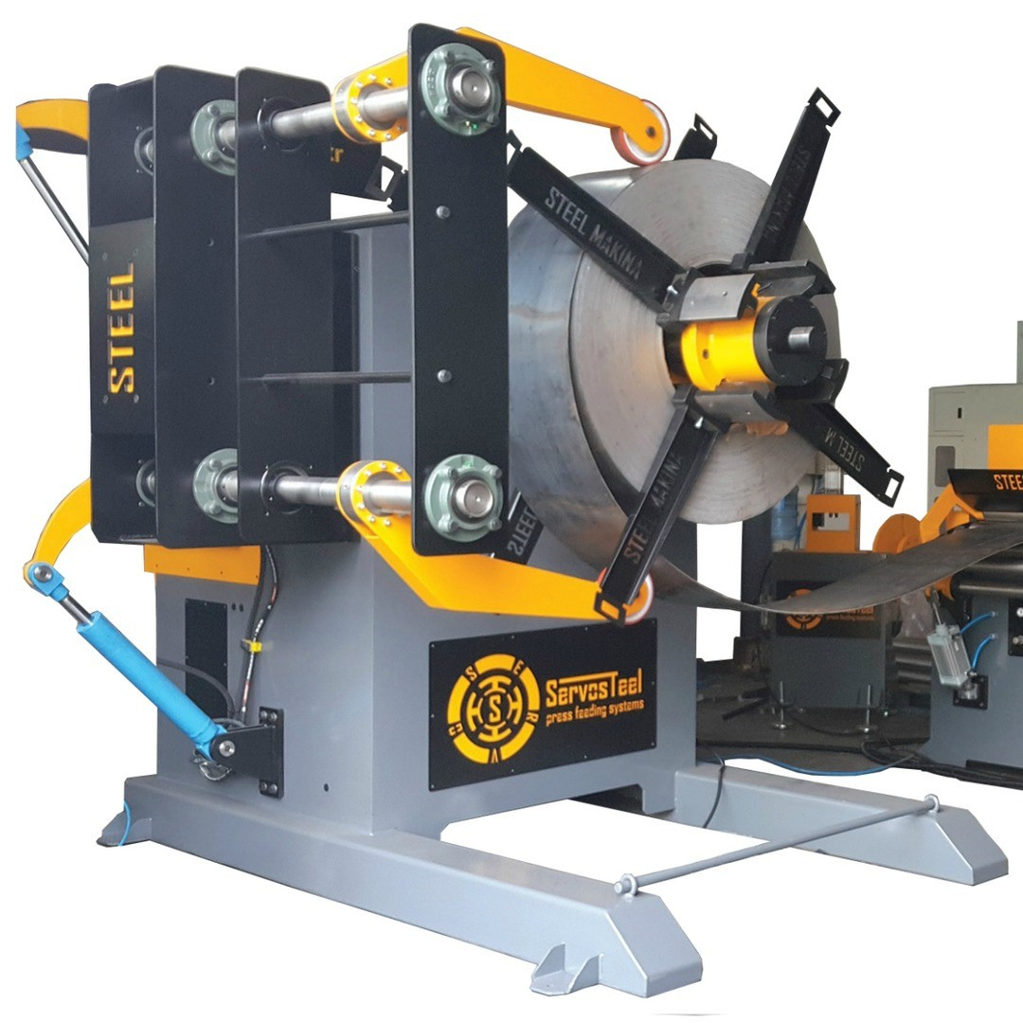Additional Equipment

**Decoilers 5 to fi5 tons**

Decoilers are available for 5 to 15 ton coils. All of our Decoilers have forward and reverse functions. When operating automatically the decoiling speed is self- regulating

and follows the speed of

the rollforming line. Decoilers can also be equipped with wheels and placed on tracks to serve several machines.

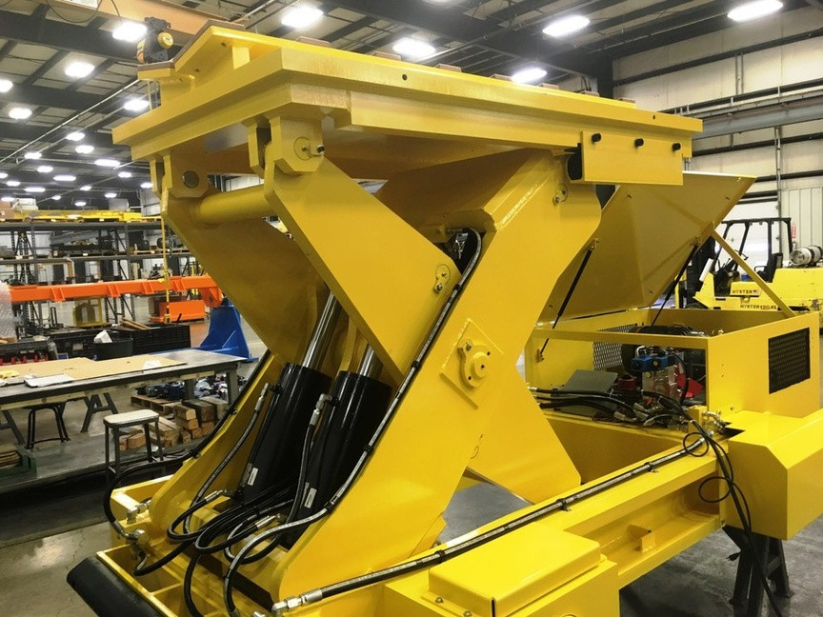**Electrically operated, 5 t**

•

|  |  |
| --- | --- |
|  | Electrical wheeling |
|  | Mechanical tightening of coil |
|  | With front support |

•

•

Hydraulically operated, 7.5 to 15 t

* With own control switches
* Hydraulic or electric wheeling, forward and reverse operation
* Hydraulic expansion of mandrel with wedge mechanism

Decoilers for 12 to 15 t are equipped with front support

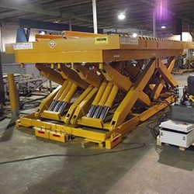Coil Car

**The use of a Coil Car reduces changeover time when removing and replacing the coil.**

* **Ascending and descending with two hydraulic cylinders**
* **Lateral movement with one hydraulic working cylinder**
* **Control switches located at de- coiler/re-coile**

Max. coil width 1500 mm

Coil weight

Available for 5 to 15 t coils

## Stackers

Additional Equipment 23

**An automatic stacker completes the whole production process. The traditional Bomb stacker with a motorized rollerline is best suited to Tile sheet and Light-trapeze rollforming machinery. As the sheet exits the rollformer it slides along the stacker wings. And when**

**the sheet is cut it drops freely onto the rollerline. The sheets are always even from one end and there is pneumatically operated pusher to slightly push every sheet to be align.**

**The optimum stacking system for our Heavy duty rollformin machinery is the Stacker with a sheet trolley and rollerline. The trolley moves with a sheet and slides from under the sheet after it has been cut and returns to receive the following sheet. On the rollerline there are pneumatically operated support rolls to support the sheet from underneath keeping it straight. After the sheet is cut they turn back to homeposition. Now the stack is easy to remove from the rollerline since it is fully accessible from above.**

**One of our latest innovations – a stacker with cushioning brushes – is the perfect solution for protecting the sensitive sheet coatings when sheets are driven colour-side down.**

**The cushioning brushes ensure a scratch-free finish for every sheet of a stack. The stacker frame consists of a dual structure, where the inner part is driven with hydraulic jacks. When the stack is complete, the inner part of the stacker is raised above all the other structures including the cushioning brushes. This leaves the stack fully- and safely-accessible from both above and the sides.**

**We also supply various tailored stacking systems, for example for weight centered stacks**

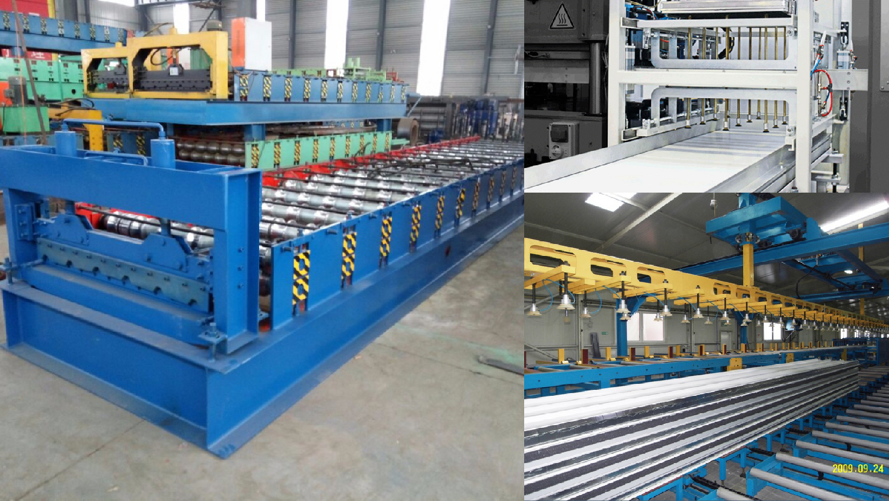

Additional Equipment

**Wrapping Machine**

Profiilikeskus Wrapping machine is designed and manufactured for easy wrapping of

the stack with plastic film. Just lift the stack onto the conveyor and turn on the line.

The entry conveyor drives the bundle through the wrapping unit and exit conveyor

receives it after wrapping. The whole process is automated.

The number of plastic film layers is regulated by adjusting the speed of the wrapping

unit. The speed of the conveyors is always set. Speed up the wrapping machine and

there will be thicker layer of plastic or slow it down and you’ll have the stack with thin

plastic wrapping.

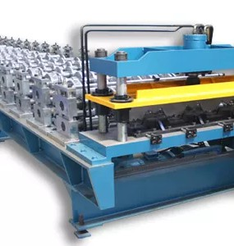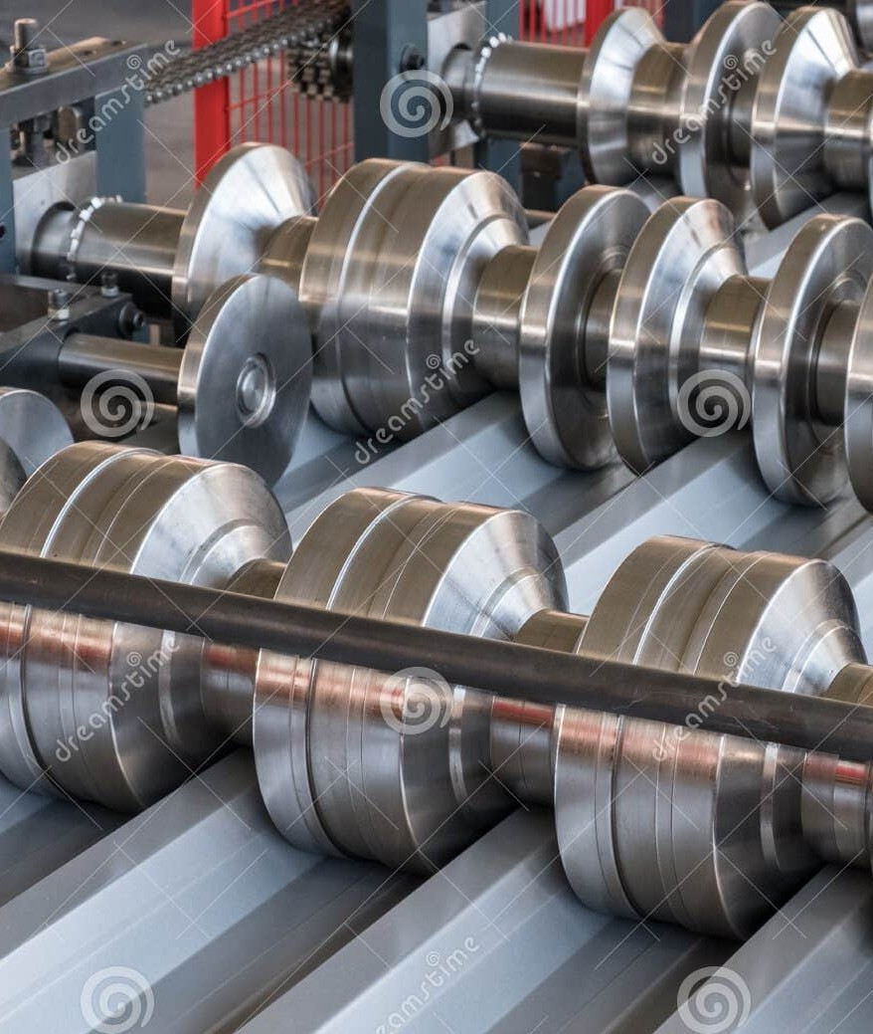

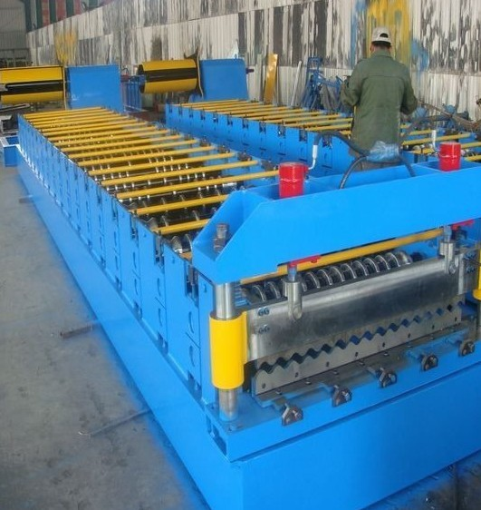

Tunnel dimensions Ø 800 mm

Ø 1300 mm

Electrically operated Double roll of stretch film Soft Start-up

Stepless speed control Ø 800 mm

Film width 300 mm

Electrical conveyors

3.5 + 3.5 m

Maximum packet size 700/700 mm

Minimum wrapping length 1000 mm

Max load 250 kg/m

Ø 1300 mm

Film width 500 mm

Electrical conveyors 6 + 8 m

Maximum packet size 1200/500 mm or 1000/700 mm Minimum wrapping length 2000 mm

Max load 500 kg/m

##### Downspout and Elbow Machine

Specification Automation

Automated Downspout Rollforming Made Available

to Everyone

Additional Equipment 25

A synchronized crimping tool can be turned on or off as needed

Model of the pipe Round

Size of the pipe

87 mm, 100 mm and 125

mm Material thickness

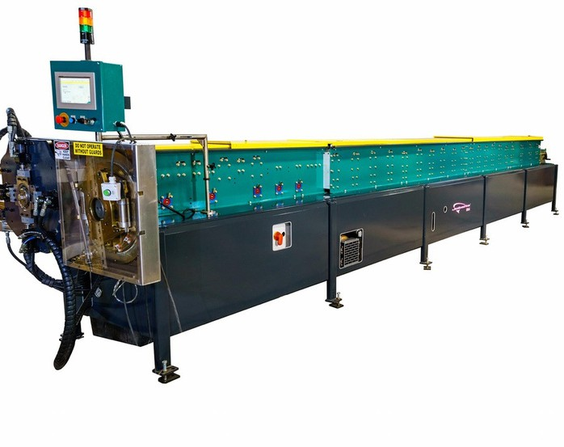The inventive design combines downspout and elbow forming functions into one compact rollformer which allows efficient, automated downspout rollforming to anyone.

* Easy to use programming

- the diagram of a product is shown on the screen

* Register for 100 standard

products

* Programming is available in millimeters or inches
* Steel 0.40–0.50 mm
* Aluminium 0.57–0.81 mm
* Copper 16 oz Width of strip

292–416 mm ±2 mm Speed

20 meters / minute or 350 elbows / hour Drive with servomotor

4.4 kW, 3 x 400 V, 50 /

60Hz Hydraulic cutting and crimping

4 kW / 125 bar Machine dimensions

* Length 9000 to 11000 mm • Width 900 mm
* Working height 1000 mm
* Weight average 4000 kg Chemically treated rollers to inhibit corrosion

Gutter Machines

Strip width 298 – 381 mm

cSapleleyd

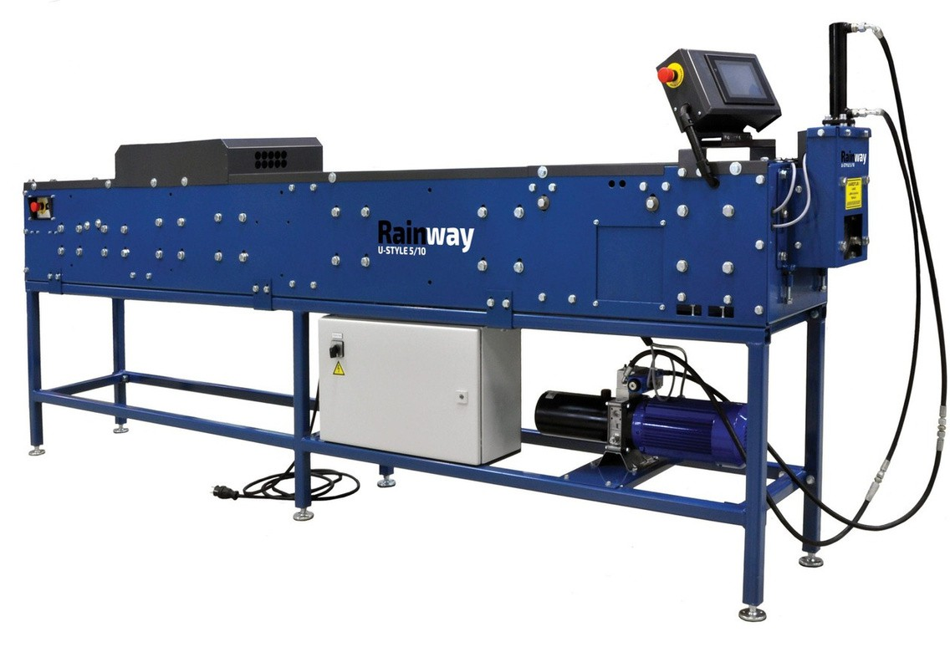1o0f mtheetegrsu/ mteinr ut

Additional Equipment

Customised Rollformers for Narrow Roofing and Cladding Profiles and Accessories

When the production volume of flashings

is high, it is more

productive and profitable to rollform the flashings instead

of using a bending machine to manufacture them. Our Gable and Straight cap flashing rollformers are electrically operated. Carefully designed forming rolls are fineturned and furnaced, which produces a hard, smooth and

easy-to-clean surface.

Depending on the profile, the post-cutter can either be

electric or hydraulic. When the profile needs punching we

equil the machine with the most modern punching technology and appropriate dies.

Our rollforming machines are easy to control, using either manual or automatic drive. After entering the length and number of pieces, just press the autodrive button and the rollformer does the rest.

In addition, we also design and manufacture machines for rollforming unique roofing and cladding profiles from narrow strip.

Our conveniently-sized decoilers for narrow strip completes the fully-automated process. Decoilers are available for strips of width 300 mm, 400 mm and 600 mm and for

coil weights of either 700 kg or 1500 kg

Material requirements Thickness

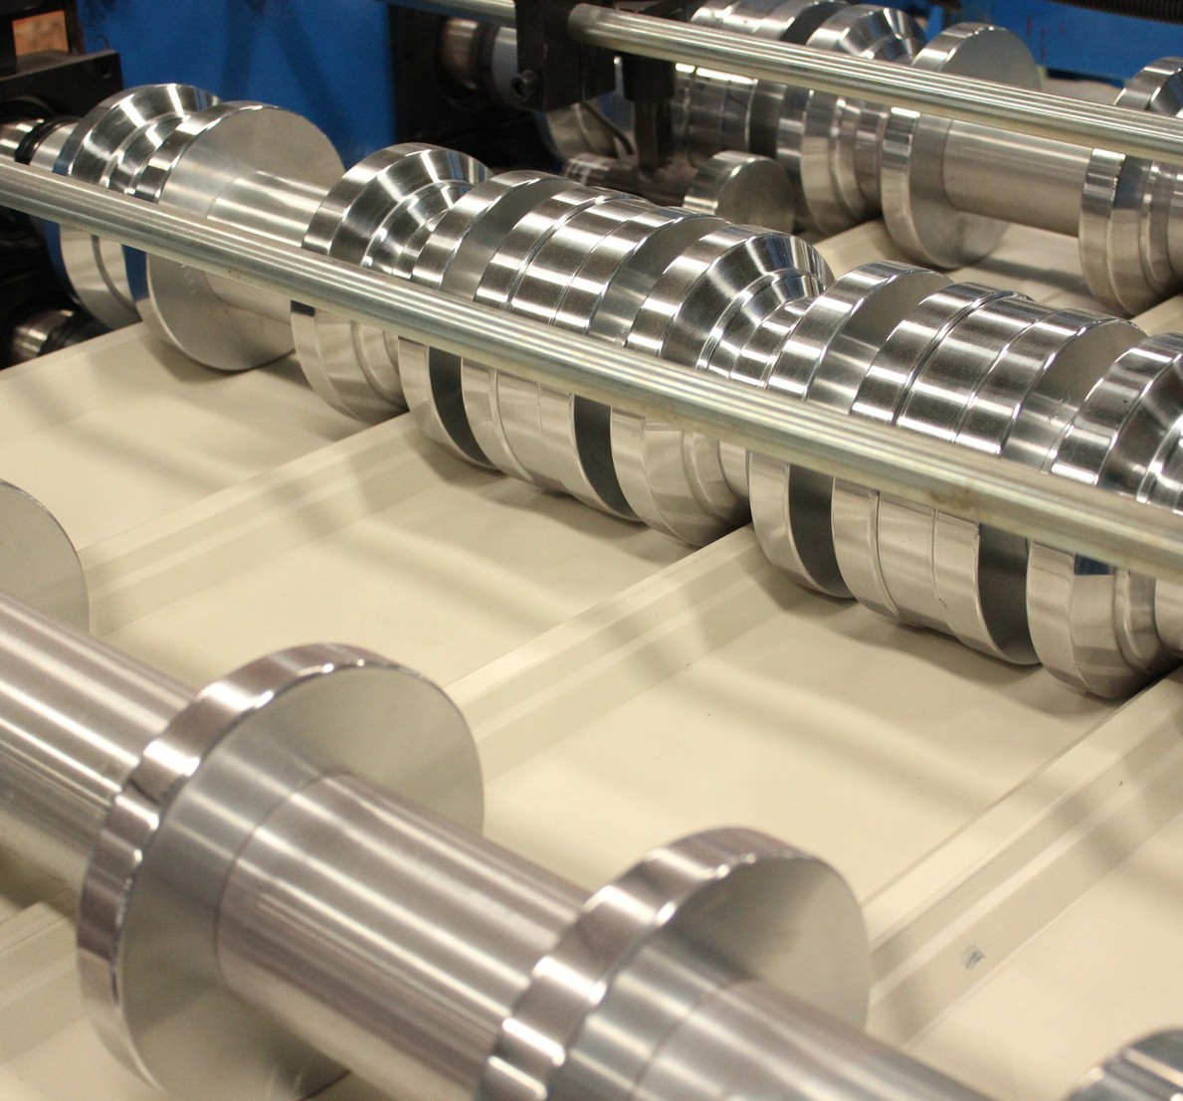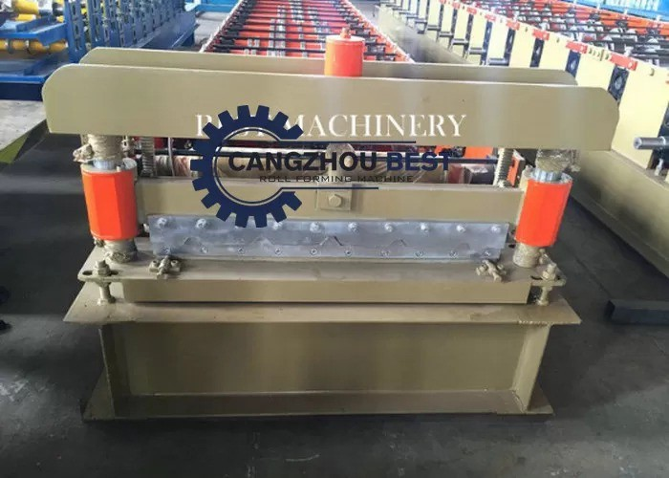

0.45 mm -1.0 mm Width of strip

100 to 600 mm

For coated and/or galvanized steel

Rolling speed 20 m/min

When production volume is high, it becomes more profitable to rollform the flashings instead of using a bending machine. Profiilikeskus offers carefully designed rollformers

e.g. for Gable and Straight Cap flashings. In addition, we design and manufacture machines for rollforming unique

roofing and cladding profiles from narrow strip

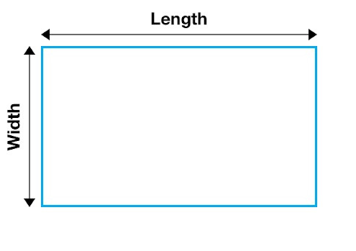

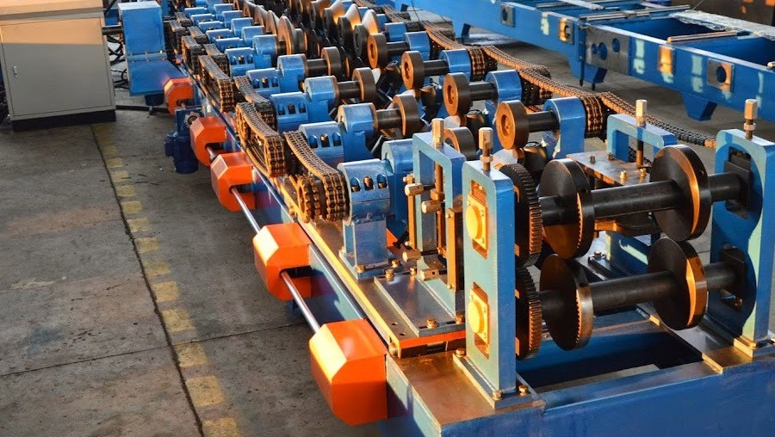100+-2

100+-3

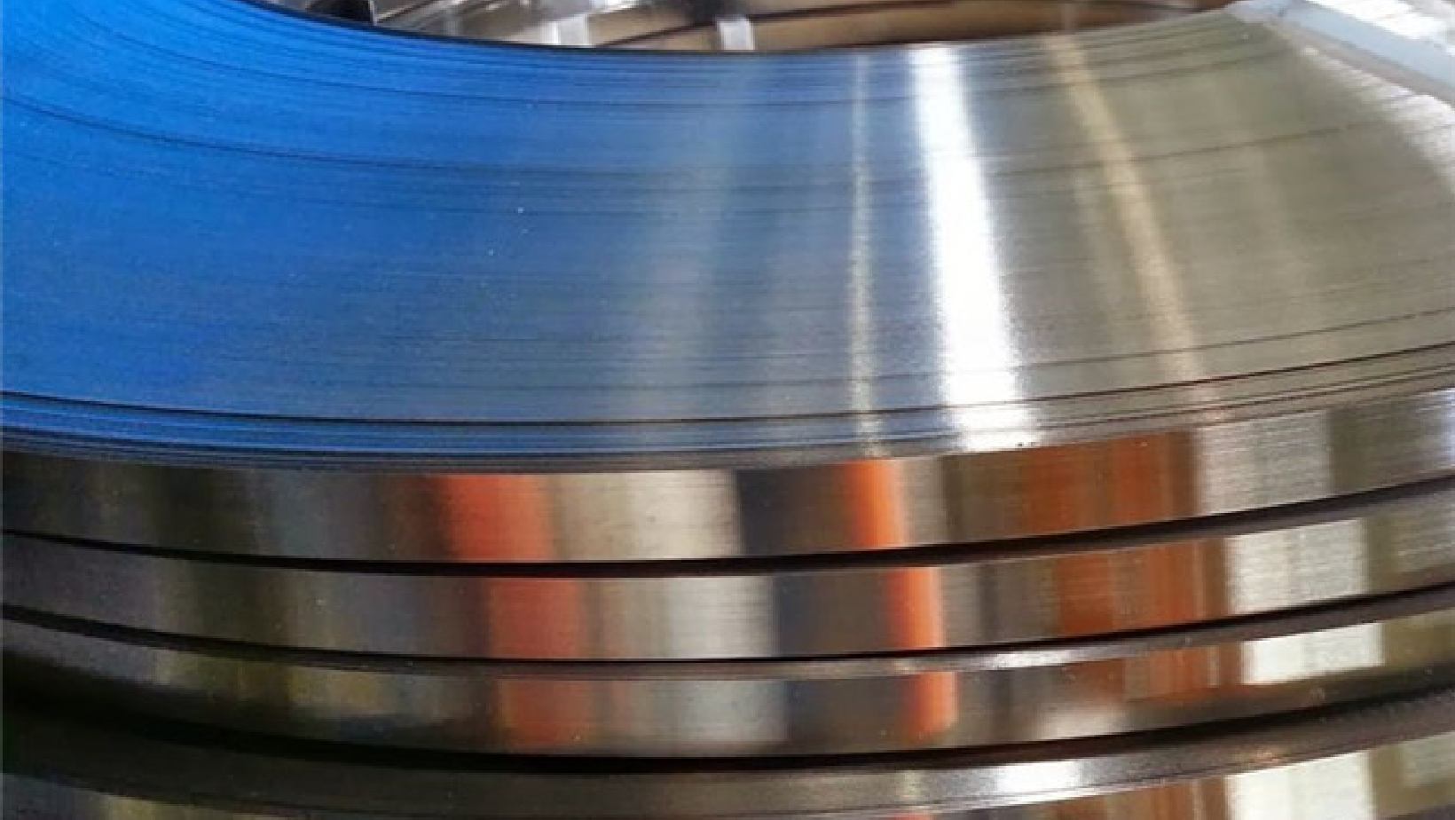[**https://balaprita**](http://balapritamrollform.com/)**mrollform.in/**

## BALA PRITAM ROLL FORM

BALA PRITAM ROLL FORM

Address - Plot No.17, Near GBL Convert School, Dabua Pali Road, Faridabad,Haryana-121004 India

Tel. +919953573713 [Con+919953573713](http://balapritamrollform.com/)

[balapritamrollforme@gmail.com](http://balapritamrollform.com/)

https://balapritamrollform.in/